Conditionals
Conditionals are used to direct the program to different sections of code. In plain English, we might have a statement “If X is [greater than, less than, equal to] Y, do this”

The comparison operators used in C++ are:

Symbol | Meaning
== | Is equal to
!= | Is not equal to
>= | Greater than or equal to
<= | Less than or equal to
> | Greater than
< | Less than
&&  and | Logical And: The condition on the left \emph{AND} the condition on the right must be true
||  or | Logical Or: The condition on the left \emph{OR} the condition on the right must be true

The most popular conditional is the if statement. An if statement looks like this:

if(variable == variable2)
{
// Code here executes only when
// the value of variable is the same as variable2
}

The key word \texttt{if} is used to start the statement. Parentheses are used to contain the conditional expression. If whatever inside the parentheses is true, then the code inside the curly braces is executed.

If only a single line of code is inside the braces, the braces may be left out.

if (variable == variable2)
{
cout << “Yes!”;
}

\noindent is the same as

if (variable == variable2)
cout << “Yes!”;

A logical demonstration of an if statement is shown in figure X.1(a)

Figure X.1 If-statement flowchart
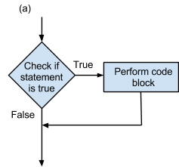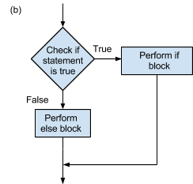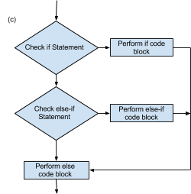

An \texttt{else} statement may be placed after an if statement, and any time the expression inside the parentheses following the if is not true, the code inside the else block is executed. For example:

if(variable == variable2)
{
// Code here executes only when
// the value of variable is the same as variable2
}
else
{
// Code here executes if they are not the same
}

An else statement is used when you want some code to execute in any other case where the if statement is not true. An example of how this works is shown in figure X-1(b).

An \texttt{else if} could also be placed after the if statement. An else if is an additional if statement checked only when the previous if statement is false. While else is a catch-all, else if tests for other conditions. Multiple else if statements can be used, and they are all checked sequentially, and if necessary, an else statement can be included at the end. Take a look at Figure X-1(c) for a flowchart example.

Here’s what the three statements would look like all together:

if(variable == variable2)
{
cout << “They are the same!” << endl;
}
else if(variable > variable2)
{
cout << “variable is bigger!” << endl;}
else
{
cout << “variable is smaller!” << endl;}
}

Note that every conditional expression is in parentheses. Conditional expressions also appear in loops (discussed in Chapter \ref{chap_loops}) and switch statements.

Switch Statements

\texttt{switch} statements (also sometimes called switch-case statements) make a menu-like set of blocks. It does the same job as many if statements, but can simplify the job when used correctly.

Example:

switch(variable):
{
case 1:
//code to execute when variable is equal to 1
break;
case 2:
//code to execute when variable is equal to 2
break;
default:
//code to execute when variable is neither 1 nor 2
break;
}
// Resume here after a break

If variable is equal to 1 then case 1 will be executed, if it is equal to 2, then case 2 will be executed, if it is equal to neither, then the code under \texttt{default:} will be executed. The cases are separated by \texttt{break;}, which forces the code to leave the switch statement's block of code.

Code 1:
switch(variable)  {  case 1:  cout << “You picked case 1. Lame.”;  break;  case 2:  cout << “Case two is way better.”;  break;  default:  cout << “WRONG!”;  break;  } | if (variable == 1)  {  cout << “You picked case 1. Lame.”;  }  else if (variable == 2)  {  cout << “Case two is way better.”;  }  else  {  cout << “WRONG!”;  }

With only a few cases, if, else if, and else statements are often easier. However, when you get to a greater number of cases, switch statements become easier.

In switch statements, only one case executes, provided that each case is followed by break. Otherwise, the program continues execution until it reaches a break statement or the end of the switch block. With an if and else if, only one branch may be executed.

Code 2:
#include <iostream>

using namespace std;

int main()
{
int choice;
double a = 5.1, b = 4.2;

cout << "<1> Addition\n";
cout << "<2> Subtraction\n";
cout << "<3> Compare\n";

cout << "Type the number of your desired option:\t";
cin >> choice;

switch(choice)
{
case 1:
cout << "The result of this addition is " << a + b << endl << endl;
break;

case 2:
cout << "The result of this subtraction is " << a - b << endl << endl;
break;

case 3:
if (a > b)
cout << "A is greater than B";
else if (a < b)
cout << "A is less than B";
else //a == b
cout << "A equals B";
break;

default:
cout << "Not an option";
break;
}

return 0;
}

Output:

User Enters | Output
//Program Start | <1> Addition  <2> Subtraction  <3> Compare  Type the number of your desired option:
1 | The result of this addition is 9.3
2 | The result of this subtraction is 0.9
3 | A is greater than B
//anything other than 1, 2, or 3 | Not an option

Review Questions
1. What is the following output?
int a = 5;
int b = 10;

if(a > b)
cout << “a is greater than b.”;
else
cout << “b is greater than a.”;

2. Why are switch statements useful?

3. When are braces “{ }” needed in an if else statement?

Review Question Answers
1. “b is greater than a.”
2. Switch statements are useful to making menus for the user.
3. Braces are needed for anything longer than 2 lines of code within the if else branch

